## Celldivisionanditssignificance:

Continuity of life depends on cell division. All cells are produced by divisions of pre-existing cell (Please recall our discussion about the cell theory in our first lecture). A cellborn after a division, proceeds to grow by macromolecular synthesis, and divides afterreaching a species-determineddivision size. Growthof a cellisan increase insize ormasswhich isan irreversibleprocess thatoccurs atall organizationallevels.

## Cellcycle:

Cell cycle can be defined as the entire sequence of events happening from the end of onenuclear division to the beginning of the next division. Cells have the property of divisionand multiplication and consist of three major phases namely mitosis (M phase) or thenucleardivision,cytokinesisorthedivisionofthecellandinterphasewherereplicationof genetic material occurs. The M phase lasts only for an hour in a period of 24 hourrequiredforaeukaryotic cell to divide. The interphasecan befurther divided into G1(gap phase 1), S (synthesis) and G2 (gap phase 2) phases (Figure 1). This division ofinterphase into three separate phases based on the timing of DNA synthesis was firstproposed in 1953 by Alma Howard and Stephen Pelc of Hammersmith Hospital, London,based on their experiments on plant meristem cells. Cell cycles can range in length fromas short as 30 minutes in a cleaving frog embryo, whose cell cycles lack both G1 and G2phases, to several months in slowly growing tissues, such as the mammalian liver. Cellsthat are no longer capable of division, whether temporarily or permanently, remain in G0phase. A cell must receive a growth-promoting signal to proceed from the quiescentstageorG0 into G1 phaseandthus reenterthecell cycle.

Damaged DNAcheckpoint

Unreplicated or

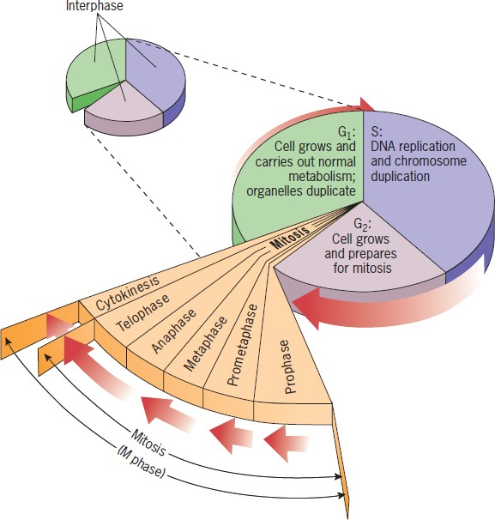

G0 damaged DNAcheckpoint

GrowthFactors

Unreplicated ordamaged DNAcheckpoint

**Figure1:Anoverviewof thecellcycle.**

ThisfigurehasbeenadaptedwithpermissionfromCellandMolecularBiologyConceptsand Experiments byKarp, 2010.

**Interphase:** During interphase the chromosomes are not visible with a light microscopewhen the cell is not undergoing mitosis. The genetic material (DNA) in the chromosomesis replicated during the period of interphase to carry out mitosis and is called S phase (Sstandsfor*synthesis*ofDNA).DNAreplicationisaccompaniedbychromosomeduplication. Before and after S, there are two periods, called G1 and G2, respectively, inwhich DNA replication does not take place. The order of cell cycle events is G1 → S →G2 → M and then followed by cytokinesis. The G1 phase, S phase and G2 phase togetherformtheinterphase.

**Events of Interphase:** The interphase is characterized by the following features: Thenuclear envelope remains intact. The chromosomes occur in the form of diffused, long,coiled and indistinctly visible chromatin fibres. The DNA amount becomes double. Dueto accumulation of ribosomal RNA (rRNA) and ribosomal proteins in the nucleolus, thesizeofthelatterisgreatly increased.Inanimalcells,adaughterpairofcentriolesoriginates near the already existing centriole and, thus, an interphase cell has two pairs ofcentrioles. In animal cells, net membrane biosynthesis increases just before cell division(mitosis). This extra membrane is stored as blebs on the surface of the cells about todivide.Events in interphasetakes placein threedistinct phases.

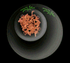

**Fig.2:Interphase**

**G1 Phase:** After the M phase of previous cell cycle, the daughter cells begin G1 ofinterphase of new cell cycle. G1 is a resting phase. It is also called first gap phase, as noDNA synthesis takes place during this stage. It is also known as the first growth phase,since it involves synthesis of RNA, proteins and membranes which leads to the growth ofnucleus and cytoplasm of each daughter cell towards their enhancing size. During G1phase, chromatin is fully extended and not distinguishable as discrete chromosomes withthelightmicroscope.Thus,itinvolvestranscriptionofthreetypesofRNAs,namely

rRNA, tRNA and mRNA; rRNA synthesis is indicated by the appearance of nucleolus inthe interphase (G1 phase) nucleus. Proteins synthesized during G1 phase (a) regulatoryproteinswhichcontrolvariouseventsofmitosis(b)enzymes(DNApolymerase)necessary for DNA synthesis of the next stage and (c) tubulin and other mitotic apparatusproteins. G1 phase is most variable as to duration it either occupies 30 to 50 per cent ofthe total time of the cell cycle. *Terminally differentiated somatic cells (end cells such asneurons and striated muscle cells) that no longer divide, are arrested usually in the G1stage,such a typeof G1phaseis called G0 phase.*

**S phase:** During the S phase or synthetic phase of interphase, replication of DNA andsynthesisofhistoneproteinsoccur.Newhistonesarerequiredinmassiveamountsimmediately at the beginning of the S period of DNA synthesis to provide the new DNAwith nucleosomes. At the end of S phase, each chromosome has two DNA molecules anda duplicate set of genes. S phase occupies roughly 35 to 45 per cent time of the cell cycle.**G2phase:**Thisisasecondgaporgrowthphaseorrestingphaseofinterphase.DuringG2 phase, synthesis of RNA and proteins continues which is required for cell growth. Itmayoccupy10to20percenttimeofcellcycle.AstheG2phasedrawstoaclose,thecellenters theM phase.

**Dividing phase:** There are two types of cell division possible. Mitosis and meosis. Themitosis(Gr.,*mitos*=thread)occursinthesomaticcellsanditismeantforthemultiplicationofcellnumberduringembryogenesisandblastogenesisofplantsandanimals. Fundamentally, it remains related with the growth of an individual from zygoteto adult stage. Mitosis starts at the culmination point of interphase (G2 phase).It is ashort period of chromosome condensation, segregation and cytoplasmic division. Mitosisis importantfor growth of organism, replacementof cells lost to naturalfriction orattrition, wear and tear and for wound healing. Hence, mitosis is remarkably similar in allanimals and plants. It is a smooth continuous process and is divided into different stagesorphases.

## Mitosis

Mitosis is a process of cell division in which each of two identical daughter cells receivesa diploid complements of chromosomes same as the diploid complement of the parentcell. It is usually followed by cytokinesis in which the cell itself divides to yield twoidenticaldaughtercells.

Thebasicsinmitosisinclude:

1. Eachchromosomeispresentasaduplicatedstructureatthebeginningofnucleardivision(2n).
2. Eachchromosomedivideslongitudinallyintoidenticalhalvesandbecomeseparatedfromeach other.
3. Theseparatedchromosomehalvesmoveinoppositedirections,andeachbecomesincludedin oneofthetwodaughternuclei thatareformed.

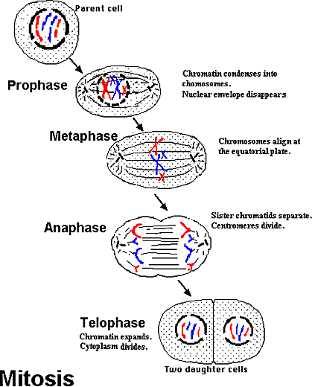Mitosis is divided into four stages: prophase, metaphase, anaphase and telophase.Thestageshavethefollowing characteristics:

**Fig.3:Mitosiscellcycle**

## Prophase:

The chromosomes are in the form of extended filaments and cannot be seen with a lightmicroscope as discrete bodies except for the presence of one or more dark bodies (i.e.nucleoli)intheinterphasestage.Thebeginningofprophaseismarkedbythecondensation of chromosomes to form visibly distinct, thin threads within the nucleus.Each chromosome is already longitudinally double, consisting of two closely associatedsubunitscalledchromatidswhichareheldtogetherbycentromere.Eachpairofchromatids is the product of the duplication of one chromosome in the S period ofinterphase. As prophase progresses, the chromosomes become shorter and thicker as aresult of intricate coiling. At the end of prophase, the nucleoli disappear and the nuclearenvelope,amembranesurroundingthenucleus,abruptlydisintegrates.

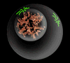

## Metaphase:

**Fig.4:Prophase**

Atthe beginning ofmetaphase,the mitotic spindle formswhichare a bipolarstructureand consist of fiber-like bundles of microtubules that extend through the cell between thepoles of the spindle. Each chromosome attached to several spindle fibers in the region ofthe centromere. The structure associated with the centromere to which the spindle fibersattach is known as the kinetochore. After the chromosomes are attached to spindle fibers,they move towards the center of the cell until all the kinetochores lie on an imaginaryplane equidistant from the spindle poles. This imaginary plane is called the metaphaseplate. Hence the chromosomes reach their maximum contraction and are easiest to countand examine for differences in morphology. The signal for chromosome alignment comesfromthekinetochore,andthechemicalnatureofthesignalseemstobethedephosphorylation of certain kinetochore-associated proteins. The role of the kinetochoreisdemonstratedbythefindingthatmetaphaseisnotdelayedbyanunattachedchromosomewhosekinetochorehasbeendestroyedbyafocusedlaserbeam.Theroleof

dephosphorylation is demonstrated through the use of an antibody that reacts specificallywithsomekinetochoreproteinsonlywhentheyarephosphorylated.Unattachedkinetochores combine strongly with the antibody, but attachment to the spindle weakensthe reaction. In chromosomes that have been surgically detached from the spindle, theantibody reaction with the kinetochore reappears. Through the signaling mechanism,when all of the kinetochores are under tension and aligned on the metaphase plate, themetaphasecheckpoint ispassed and the cell continues theprocess ofdivision.

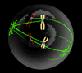 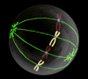

**Fig.5:Prometaphase Fig.6:Metaphase**

## Anaphase:

In anaphase, the centromeres divide longitudinally, and the two sister chromatids of eachchromosome move toward opposite poles of the spindle. Once the centromere divide,eachsisterchromatidistreatedasaseparatechromosome.Chromosomemovementresults from progressive shortening of the spindle fibers attached to the centromeres,which pulls the chromosomes in opposite directions toward the poles. At the completionof anaphase, the chromosomes lie in two groups near opposite poles of the spindle. Eachgroupcontainsthesamenumberofchromosomesthatwaspresentintheoriginalinterphasenucleus.

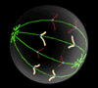

**Fig.7:Anaphase**

## Telophase:

In telophase, a nuclear envelope forms around each group of chromosomes, nucleoli areformed,andthespindledisappears.Thechromosomesundergoareversalofcondensation until and unless they are no longer visible as discrete entities. The twodaughter nuclei slowly goes to interphase stage the cytoplasm of the cell divides into twobymeans ofagraduallydeepeningfurrowaroundtheperiphery.

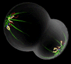

## Cytokinesis:

**Fig.8:Telophase**

The chromosomes moved close to the spindle pole regions, and the spindle mid-zonebegins to clear. In this middle region of the spindle, a thin line of vesicles begins toaccumulate. This vesicle aggregation is an indication to the formation of a new cell wallthatwillbesituatedmidwayalongthelengthoftheoriginalcellandhenceformboundarybetween thenewlyseparatingdaughtercells.

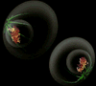

**Fig.9:Cytokinesis**

## InterestingFacts:

* ThedrugColchicinearrestscellcycleproression.
* Adisregulationofthecellcyclecomponentsmayleadtotumorformation.
* Several methods can be used to synchronise cell cultures by halting the cell cycleat a particular phase. For example, serum starvation and treatment with thymidineoraphidicolin halt thecell in theG1 phase.
* Someorganismscanregeneratebody partsbymitosis.Forexample,starfishregeneratelost arms through mitosis.
* Someorganismsproducegeneticallysimilaroffspringthroughasexualreproduction.Forexample, thehydra.
* Although errors in mitosis are rare, the process may go wrong, especially duringearlycellulardivisions in thezygote.
* Endomitosisisavariantofmitosiswithoutnuclearorcellulardivision,resultingincells with manycopiesofthesamechromosomeoccupyingasinglenucleus.

# Meiosis

## Meiosis

In the last chapteryou studied about mitosis as cell division. Meiosis is the second typeof cell division occurring in the gametic cells. Meiosis was first described by the Germanbiologist Oscar Hertwig in 1876 in the sea urchin egg. Meiosis is the process of celldivision that occurs only in the germ cells of eukaryotes unlike mitosis which takes placein the somatic cells. Unlike mitosis meiosis is only initiated once in the life cycle ofeukaryotes **(John 1990)**. The cells produced by meiosis are known as gametes or spores.Meiosis leads to reduction of chromosome number, of a diploid cell (2n) to half (n).Meiosis begins with one diploid cell containing two copies of each chromosome andultimately produces four haploid cells containing one copy of each chromosome whichhave undergone recombination, giving rise to genetic diversity in the offspring. Highorder transcriptional and translational control of genes known as “meiome” controls theeventsofmeiosis **(Snustad 2008)**.

## CellcycleandMeiosis

The preparatory steps that lead up to meiosis are identical in pattern to mitosis and occursintheinterphaseofthemitoticcellcycle.InterphaseisfollowedbymeiosisIandthen



meiosisII.

**Meio sis**

**Proph**

**G2**

**G1**

**S**

**MeioticCommitm**

**Mitosis**

**S**

**PreMeiotic**

**MeioticReadiness**

**Fig1:Positionof meiosisinthe Cellcycle.**



**G2**

## Stagesofmeiosis

Meiosis can be separated into two phases which are meiosis I and meiosis II and they canbe further subdivided into numerous phases which have particular identifiable features.Theyhavebeen broadlydescribed in thefollowingsections.

## MeiosisI

In meiosisI,chromosomes in a diploid cellsegregate, producing four haploid cellsgeneratinggeneticdiversity. ThestagesofmeiosisIare:

## A.ProphaseI

DuringthisphaseDNAisexchangedbetweenhomologouschromosomesorsisterchromatids in a process called homologous recombination. The replicated chromosomesarecalledbivalentsandhavetwochromosomesandfourchromatids,withonechromosomecomingfromeachparent.ThisphasecanbefurthersubdividedintoLeptotene,Zygotene,Pachytene,DiploteneandDiakinesis.Thedifferentstageshavebeenpictoriallypresented in thefollowingsection.

|  |
| --- |
| **1.Leptotene**  Itisaveryshortdurationstageandprogressive condensation of chromosomestakes place. In this stage the chromosomesare first observed as thin threads and aresaid to be in a diffused state. The sisterchromatidsaretightlypackedandindistinguishablefrom oneanother. |
| **2.Zygotene**  Chromosome duplication occurs and thehomologouschromosomespairupwitheachother.  *Purpleandbluerepresenthomologous*  *duplicatedchromosomes.* |

## Nucleus

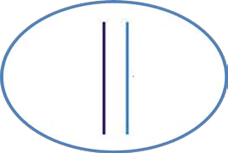

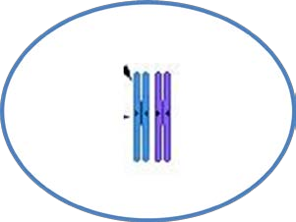

**3.Pachytene**

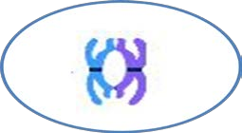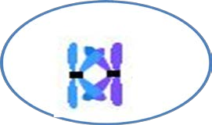Chromosomalcrossover(crossingover)occursbychiasmaformationbetweenhomologouschromosomes.Nonsisterchromatids of homologous chromosomesmay exchange segments over regions ofhomologybyaprocesscalledrecombination. The region where crossingoveroccursis knownaschiasmata.

|  |
| --- |
| **4.Diplotene**  Homologous chromosomes separate fromone another a little but remain attached atthechiasmata. |
| **5.Diakinesis**  Chromosomes condense further during thediakinesis stage.This is the first point inmeiosiswherethefourpartsofthetetrads  areactuallyvisible.Sitesofcrossingover |

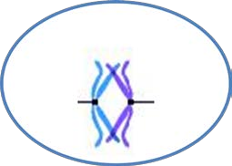

Chiasmata

Chiasmata

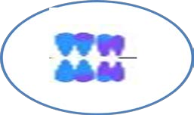entangle together, effectively overlapping,making chiasmata clearly visible. The restofthestagecloselyresemblesprometaphaseofmitosis;thenucleolidisappear,thenuclearmembranedisintegrates into vesicles, and the meioticspindlebegins to form.

**Figure2:StagesofMeiosisI**

## MetaphaseI

Homologouspairsmovetogetheralongthemetaphaseplate:Askinetochoremicrotubules from both centrioles attach to their respective kinetochores, the homologouschromosomes align along an equatorial plane that bisects the spindle, due to continuouscounterbalancing forces exerted on the bivalents by the microtubules emanating from thetwo kinetochores of homologous chromosomes. The physical basis of the independentassortmentofchromosomesistherandomorientationofeachbivalentalongthemetaphase plate, with respect to the orientation of the other bivalents along the sameequatorialline(seeFig3).

## AnaphaseI

Homologouschromosomesarepulledapartbyshorteningofspindlefibres,eachchromosomestillcontainingapairofsisterchromatids.Thecellthenelongatesinpreparationfordivision down thecenter(seeFig3).

## AnaphaseI

Chromosomesareattwodifferentpolesinthecellandthenuclearenvelopesmayreform, or the cell may quickly start meiosis II. Each daughter cell now has half thenumber of chromosomes but each chromosome consists of a pair of chromatids (see Fig3).

## TelophaseI

The two daughter cell now has half the number of chromosomes but each chromosomeconsists of a pair of chromatids. The spindle networks disappear, and a new nuclearmembraneforms.Thechromosomesdecondensationoccursandfinallycytokinesispinches the cell membrane in animal cells or the formation of the cell wall in plant cells,occurs,completingthecreation oftwo daughtercells.

## MeiosisII

Meiosis II is the second stage of the meiotic process. The overall process is similar tomitosis. The end result is production of four haploid cells. The four main steps of MeiosisIIare:ProphaseII,Metaphase II,Anaphase II,and Telophase II(seeFig3).

## ProphaseII

In prophase II the nucleoli and nuclear envelope disappear. Centrioles move to oppositepolesand arrangespindle fibers forthesecond meioticdivision(seeFig3).

## MetaphaseII

In metaphase II, the centromeres contain two kinetochores that attach to spindle fibersfrom the centrosomes (centrioles) at each pole. The new equatorial metaphase plate isrotated by 90 degrees when compared to meiosis I, perpendicular to the previous plate(see Fig3).

## AnaphaseII

ThisisfollowedbyanaphaseII,wherethecentromeresarecleaved,allowingmicrotubules attached to the kinetochores to pull the sister chromatids apart. The sisterchromatidsbyconventionarenowcalledsisterchromosomesastheymovetowardopposingpoles (seeFig3).

## TelophaseII

The process ends with telophase II, which is similar to telophase I, and is marked byuncoiling and lengthening of the chromosomes and the disappearance of the spindle.Nuclear envelopes reform and cleavage or cell wall formation eventually produces a totalof four daughter cells, each with a haploid set of chromosomes. Meiosis is now completeandends up with fournewdaughtercells (seeFig3).

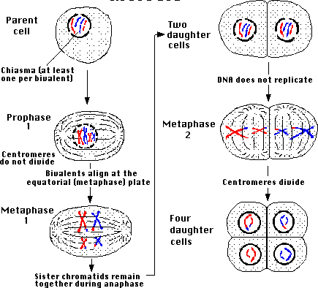

**Figure3:Events inmeiosisIandII**

## Thedifferencebetweenmaleandfemalemeiosis

There aremainlythreedifferences betweenmaleandfemalemeiosis

1. Malemeiosiscreatessperm,whilefemalemeiosiscreates eggs.
2. Male meiosis takes place in the testicles, while female meiosis takes place in theovaries.
3. AmalewillgenerallyhaveoneXandoneYsexchromosome,whileafemalehavetwo X chromosomes, however only one of the two is active and the other is known as abarrbody . During meiosis I, the sex chromosomes separate and enter different sperm oregg cells (gametes). Males will end up with one half X sperm and the other half Y sperm,while females will all have X eggs because they had no Y chromosome in the first place.There are more subtle differences though. At the end of meiosis I females have twodaughter cells and meiosis II only occurs if and when fertilization occurs by a sperm cell.At that time both daughter cells divide to form 4 cells and of the 4 cells formed, 3 arediscarded as polar bodies and the 4th cell having an enhanced cytoplasmic componentcombinesitsnuclearcomponentwiththespermcell'snuclearcomponentandcrossing

over occurs to form the embryo which then begins to divide via mitosis to become twocells,then fourand so on.